Reference: Draxler, R. R., & Rolph, G. D. (2003). HYSPLIT (HYbrid Single-Particle Lagrangian Integrated Trajectory) model access via NOAA ARL READY website (http://www. arl. noaa. gov/ready/hysplit4. html). NOAA Air Resources Laboratory, Silver Spring.

BRT 3/24-4/3/14 event on 3/27 (BMr14) PM10 160µg/m³ & 4/2 (BA14a) PM10 519µg/m³. Wind direction 3/27 279°, 4/2 269°
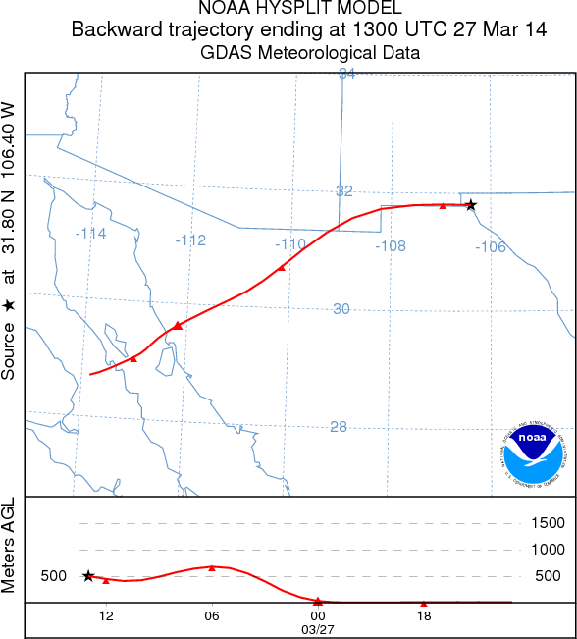

4/2/14
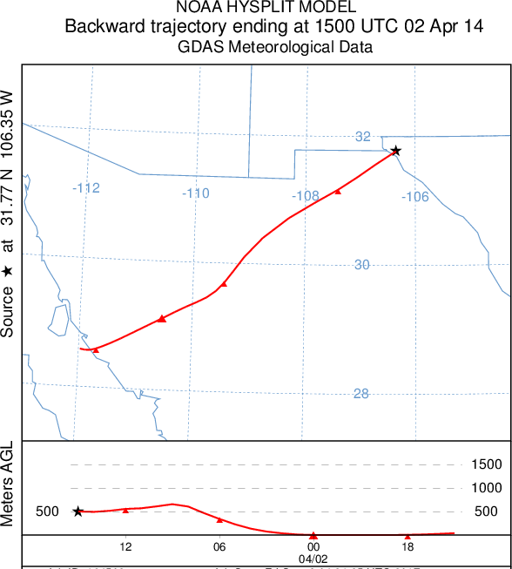

BRT 4/13-4/18/13 event on 4/17 (BA13), PM10 1019.5 µg/m³, wind direction 267°

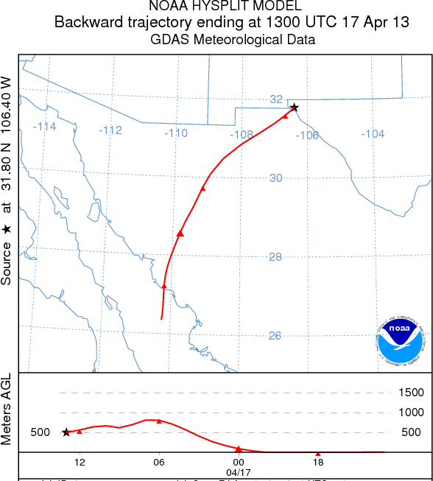

BRT 4/15-4/20/14 event on 4/18/14 (BA14b) 82µg/m³, wind direction 194°

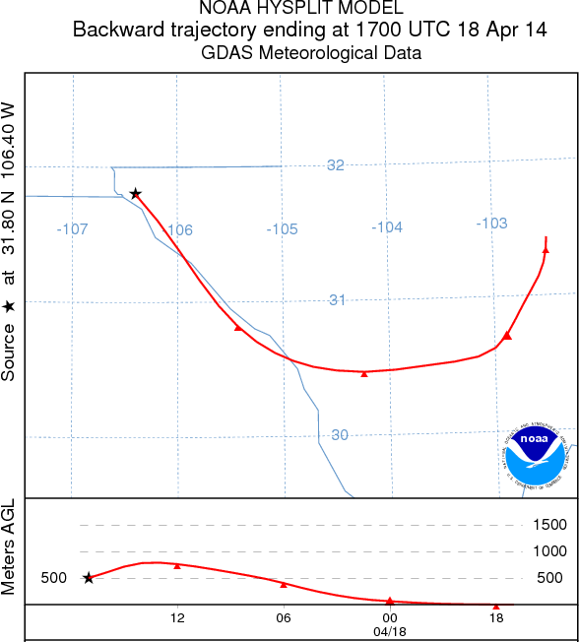

BRT 5/4-5/8/14 event on 5/7/14 (BMy14a). PM10 1112.4 µg/m³ Wind direction 271°

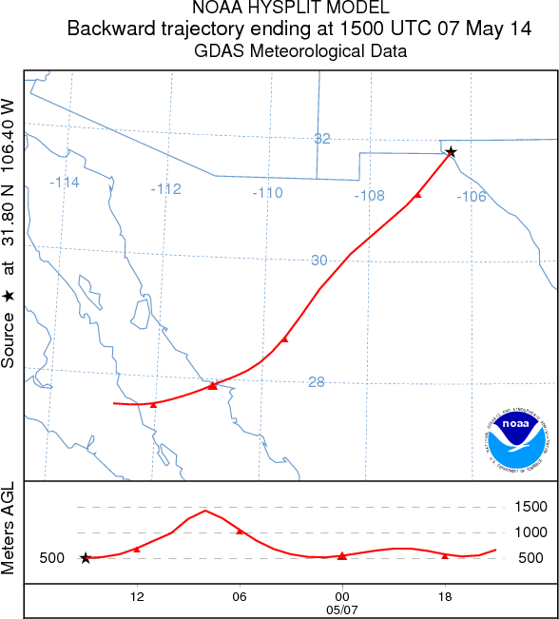

BRT 12/13/4-2/15/15 Events on:

12/25 (BD14) PM10 135.5 µg/m³, wind direction 271°
1/24 (BJ15) PM10 113.4 µg/m³, wind direction 228°
2/5 (BF15) PM10 155.0 µg/m³, wind direction 238°

12/25:
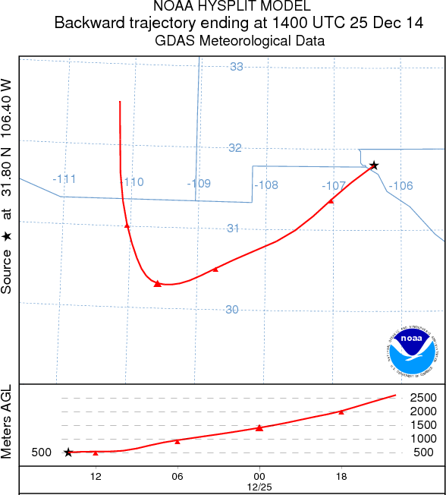

1/25:

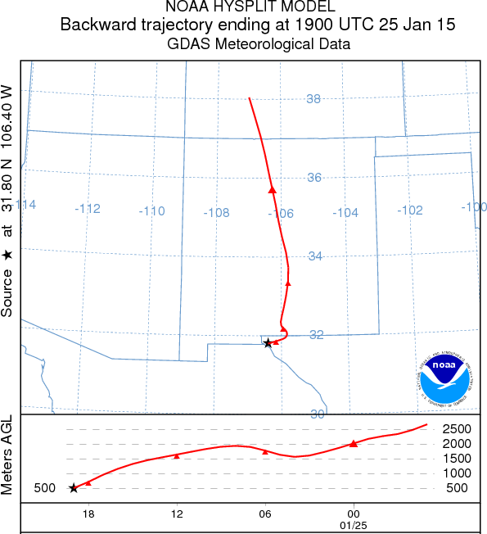

2/5:

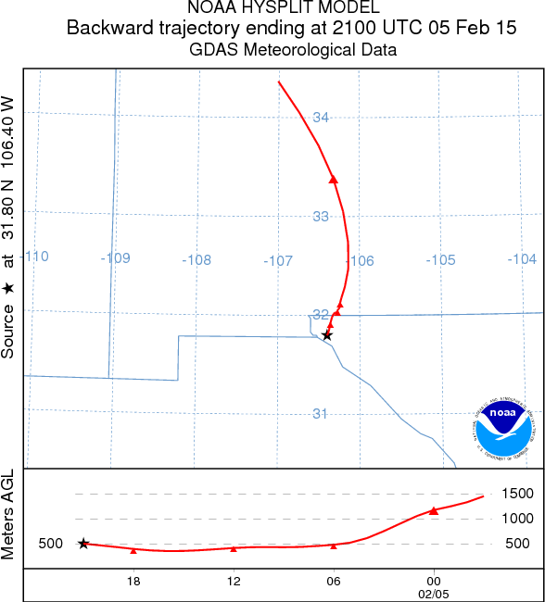

BRT 5/3-5/30/15 event on 5/14/15 (BMy15) PM10 155.0 µg/m³ wind direction 262°

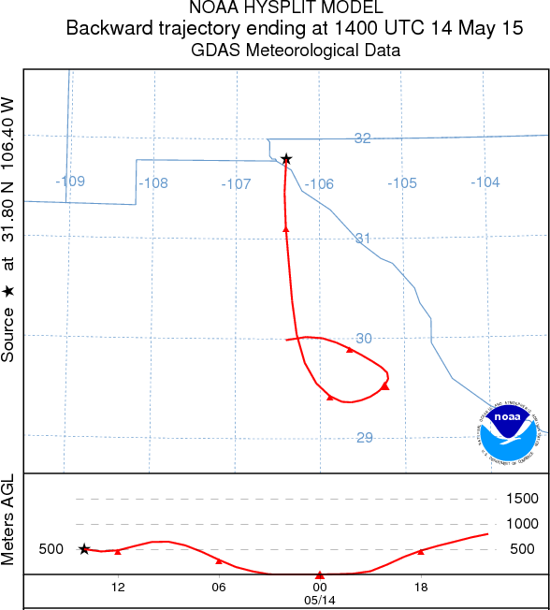

BRT 4/12-5/3/15 event on 4/27/15 (BA15) PM10 166.0 µg/m³, wind direction 42°
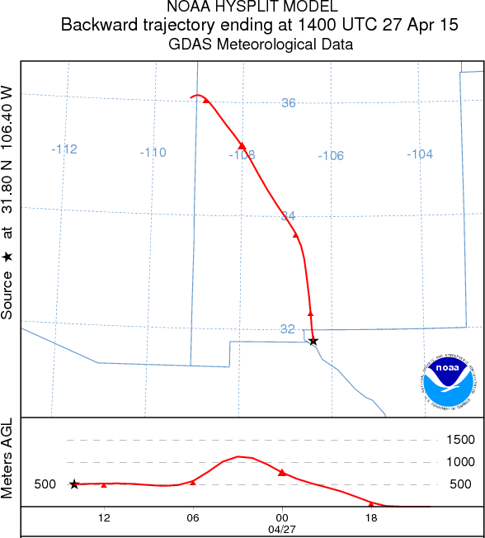

BRT 5/10-5/22/14 event on 5/11/14 (BMy14-2) PM10 285.8 µg/m³, wind direction 264°

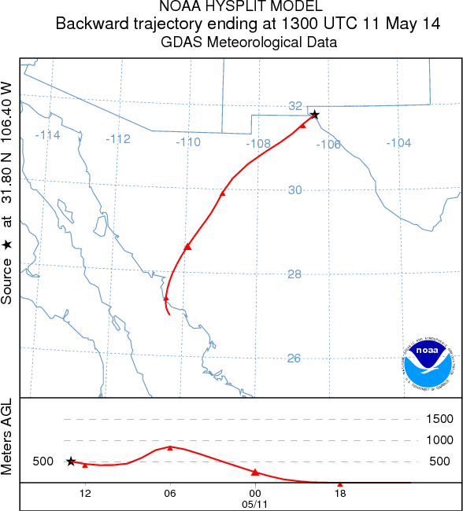

BRT 11/15-11/16/16 event on 11/16/15 (BN15), PM10 516.8 µg/m³, wind direction 296°

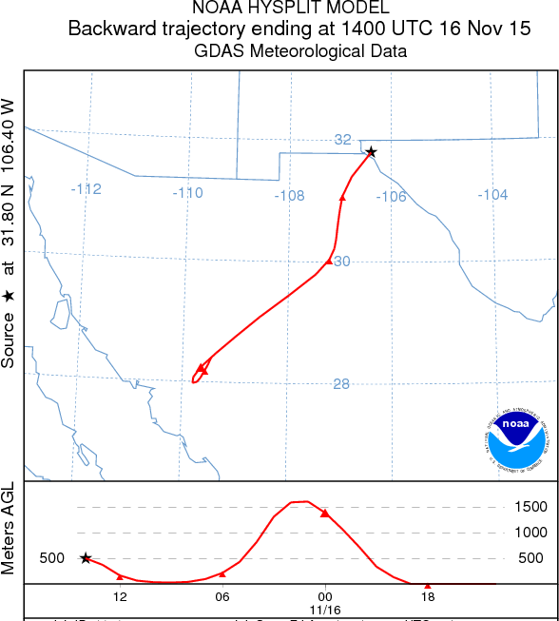

BRT 3/21-3/24/16 event on 3/22/16 (BMr16) PM10 256.5 µg/m³, wind direction 249°

